**Module 2**

**Project Review**

Kyle Keiper

Computer Science, SNHU

CS-330 Computer Graphics & Visualization

Professor Phillips

Nov 5, 2022

Module 2: Project Proposal

I took a picture of my kitchen table with items on it. These items consist of a set of salt and pepper shakers, a candy bowl with decorative pumpkins in it, a set of placemats, a paper towel holder and my wife’s purse. The simple shapes are the candy bowl, the decorative pumpkins, and the placemats. The complex shapes are the salt and pepper shakers and my wife’s purse. See the image below for reference.

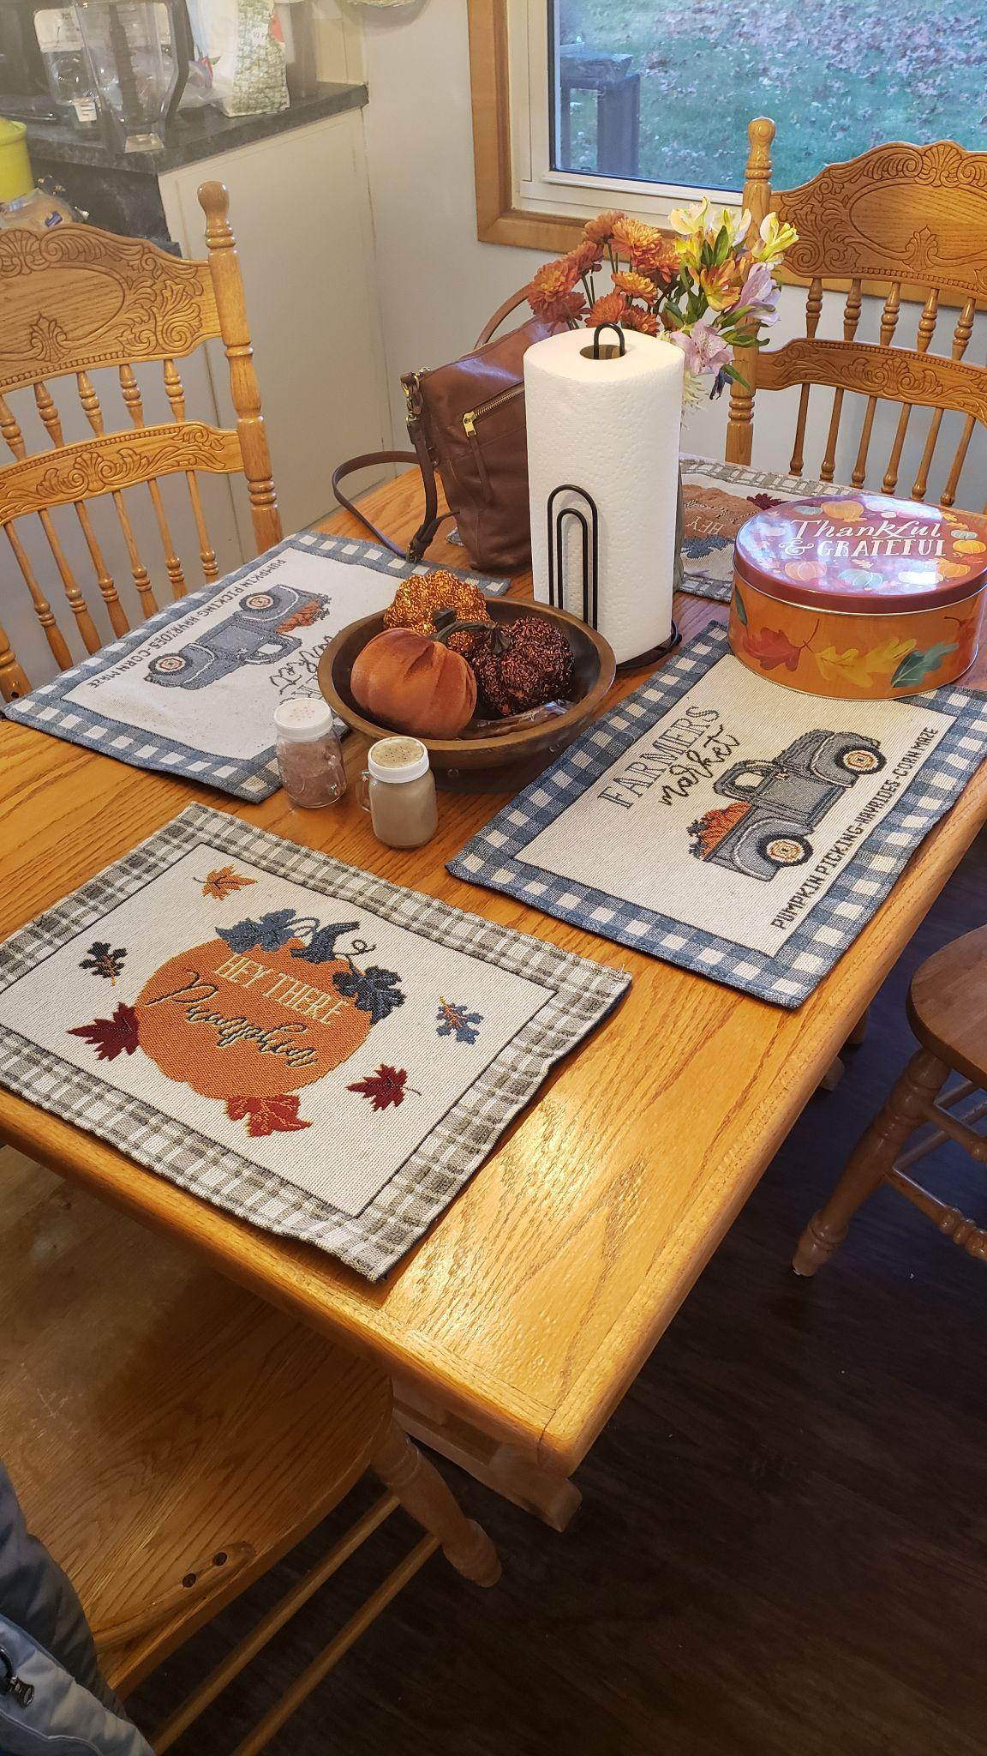

The objects that will be created in 3D are the placemats, because they’re a simple plane; the candy bowl, because it’s a half-sphere; the purse, because it’s a triangular pyramid combined with a couple cylinders to form the purse strap; and lastly, the salt and pepper shakers as they are the most complex, using a cylinder for the main body, three cylinders for the handle, a cylinder for the cap, and finally, a circle for the grate. Since we have to include a plane to use as the ground, I would use the table’s surface as the plane for the scene.